Quiz Generator in Java

Assignment 1

Submitted to: Sir Fahad Satti

Name: Ubaid ur Rehman

Class: BSCS-5B

Reg. number: 00000123495

Subject: Advanced Programming

Date: 12/31/17

# Introduction

Quizzer is a software, developed in java, which makes it easier for students and teachers to attempt and make quizzes.

This program entertains two types of users

1. Teacher (Who can make quiz)
2. Student (Who can attempt quiz)

Types of question in quiz

1. Multiple choice questions (MCQs)
2. True/False choices question
3. Numeric input answers

## Learning

While doing this assignment, I got the concepts of following:

* MVC Pattern
* Maven basic concept
* Unit tests and Junit
* Github
* Java Programming

**Sample Run**

# Login

## Description

User can login entering the credentials. (credentials can be changed through the file ”LoginData”)

* For teacher:
  + Username: teacher
  + Password: test123
* For student
  + Username: student
  + Password: test123

## Screen shot for teacher

### Login

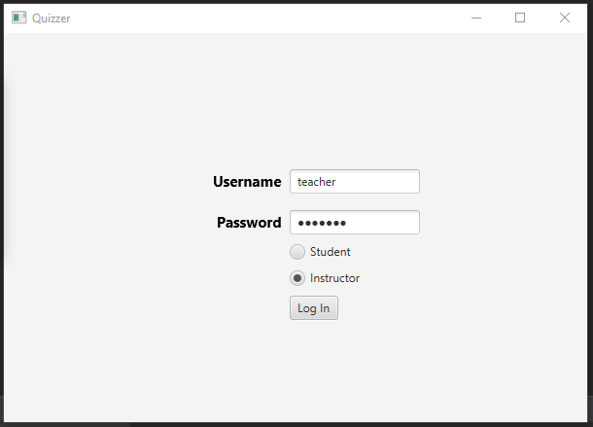

### Login Success

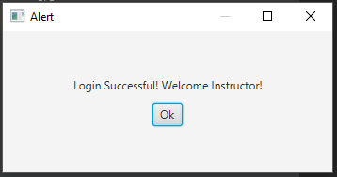

### Teacher Main View

After logging in as a teacher, user sees this screen

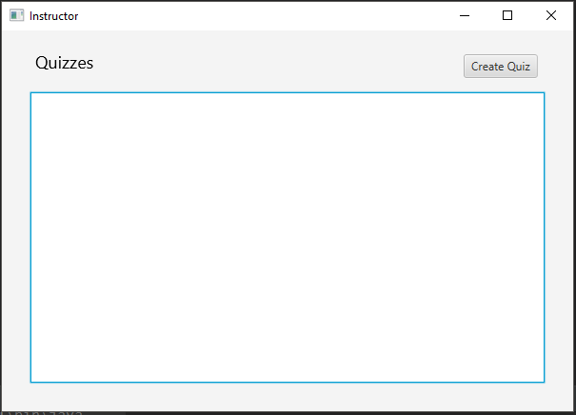

### Create Quiz

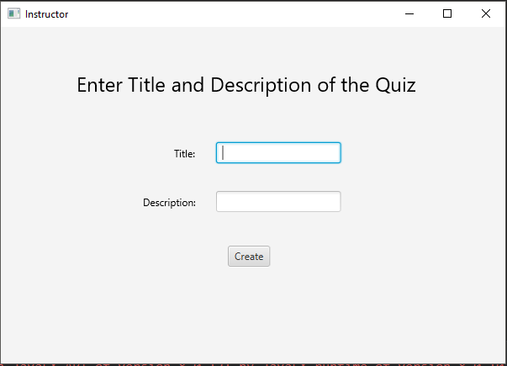

### Add Question

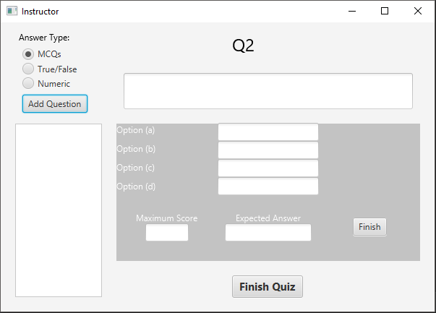

## Screen shots for Student

### Login

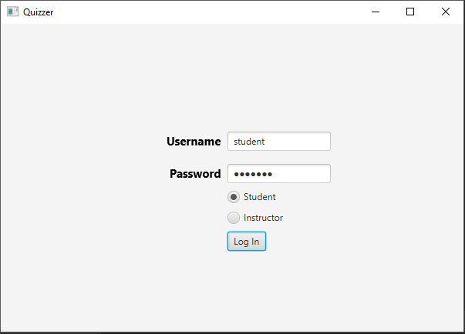

### Login Success

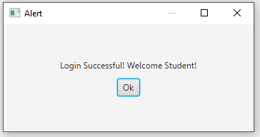

### Attempt Quiz

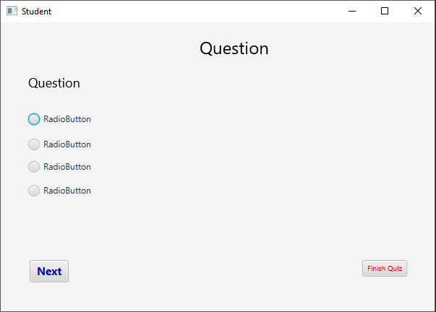

**Github**

**Repo link:**

https://github.com/uurehman/quiz-application-in-java